DOCUMENTATION

Objective:
The objective of this project is to analyze customer churn patterns in an e-commerce business using customer and transactional data. The project focuses on understanding factors such as customer tenure, payment preferences, satisfaction scores, purchase behavior, complaints, cashback, and warehouse distance. The analysis aims to identify important patterns and provide useful insights that can help the business reduce customer churn, improve customer satisfaction, and strengthen long-term customer retention.

Project Steps and Objectives:

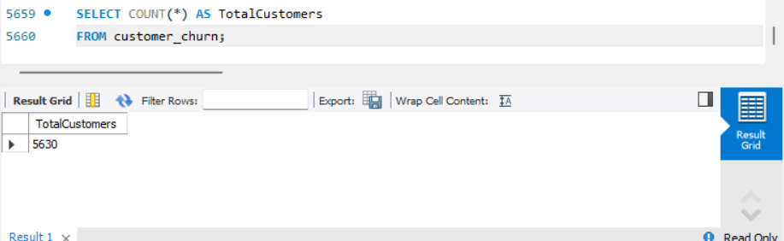

Data Cleaning:
Handling Missing Values and Outliers:
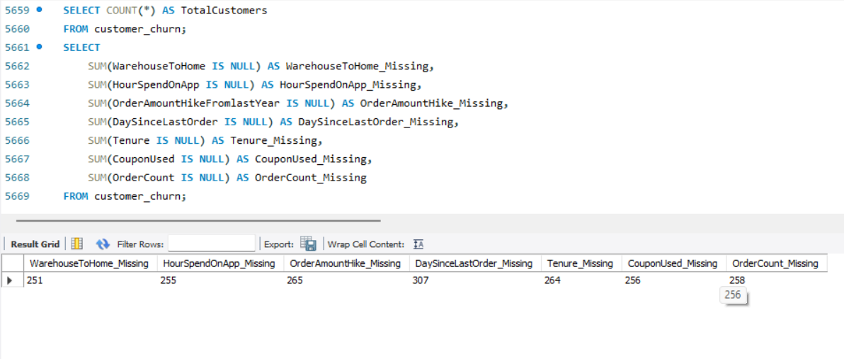
➢ Impute mean for the following columns, and round off to the nearest integer if required: WarehouseToHome, HourSpendOnApp, OrderAmountHikeFromlastYear, DaySinceLastOrder.

➢ Impute mode for the following columns: Tenure, CouponUsed, OrderCount.

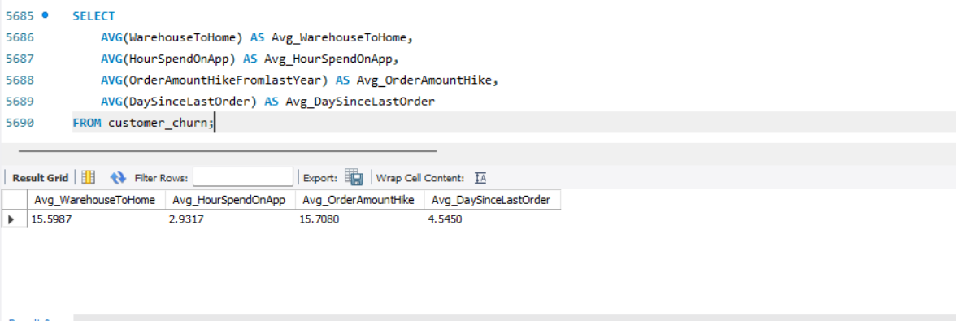
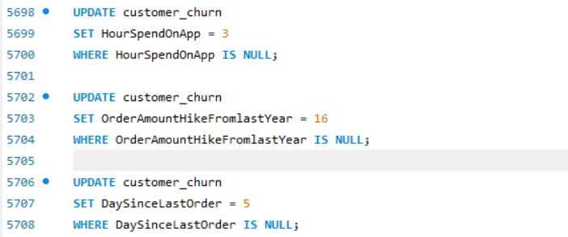
➢ Handle outliers in the 'WarehouseToHome' column by deleting rows where the values are greater than 100.
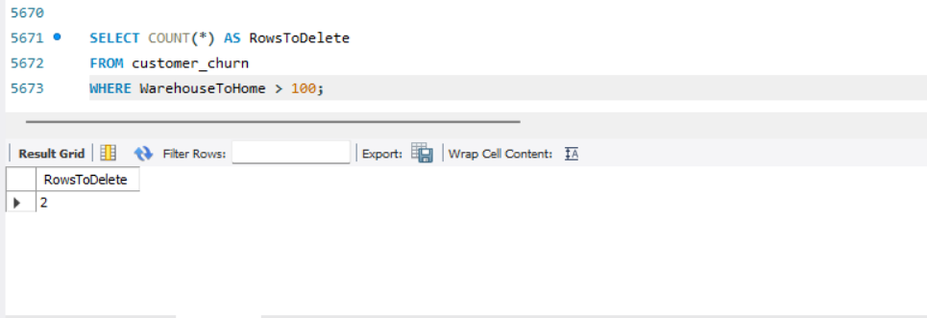
Dealing with Inconsistencies:
➢Replace occurrences of “Phone” in the 'PreferredLoginDevice' column and “Mobile” in the 'PreferedOrderCat' column with “Mobile Phone” to ensure uniformity.


➢ Standardize payment mode values: Replace "COD" with "Cash on Delivery" and "CC" with "Credit Card" in the PreferredPaymentMode column
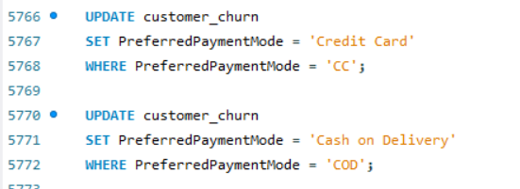

Data Transformation:
Column Renaming:
➢Rename the column "PreferedOrderCat" to "PreferredOrderCat".
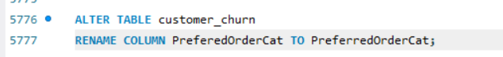

➢Rename the column "HourSpendOnApp" to "HoursSpentOnApp".


Creating New Columns:
➢ Create a new column named ‘ComplaintReceived’ with values "Yes" if the corresponding value in the ‘Complain’ is 1, and "No" otherwise.
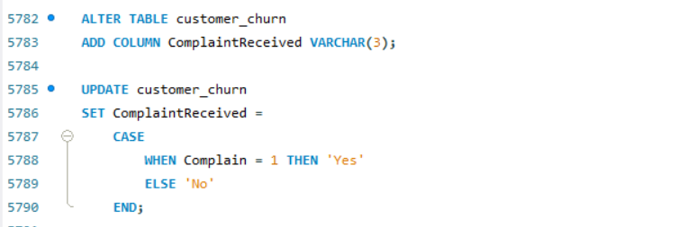

➢ Create a new column named 'ChurnStatus'. Set its value to “Churned” if the corresponding value in the 'Churn' column is 1, else assign “Active”
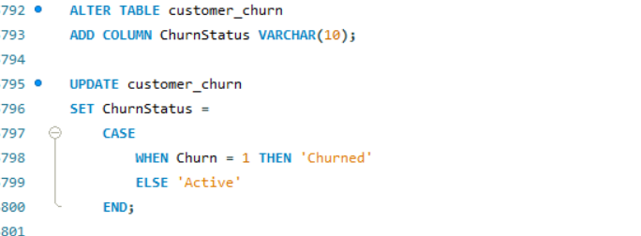
Column Dropping:
➢ Drop the columns "Churn" and "Complain" from the table.
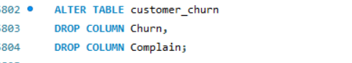
Data Exploration and Analysis:
➢ Retrieve the count of churned and active customers from the dataset.

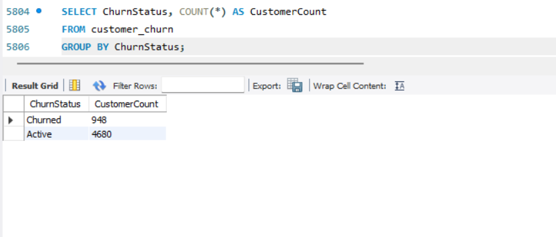
➢ Display the average tenure and total cashback amount of customers who churned.
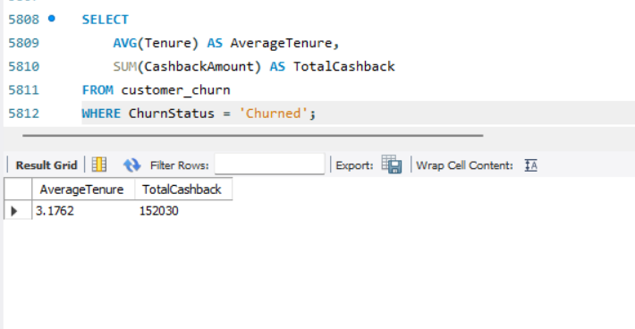
➢ Determine the percentage of churned customers who complained.
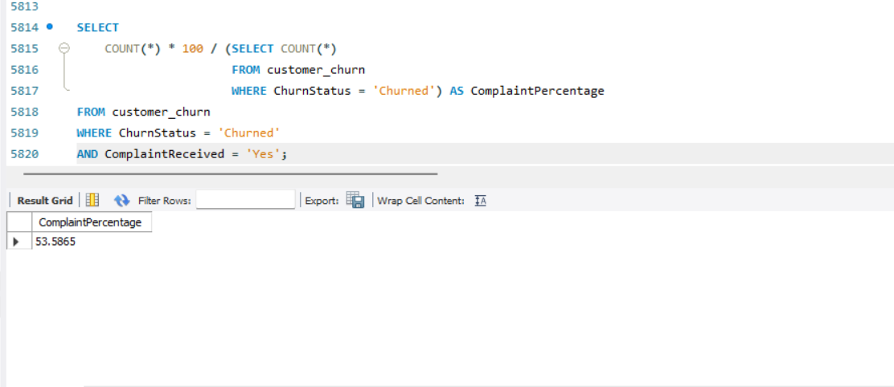
➢ Identify the city tier with the highest number of churned customers whose preferred order category is Laptop & Accessory.
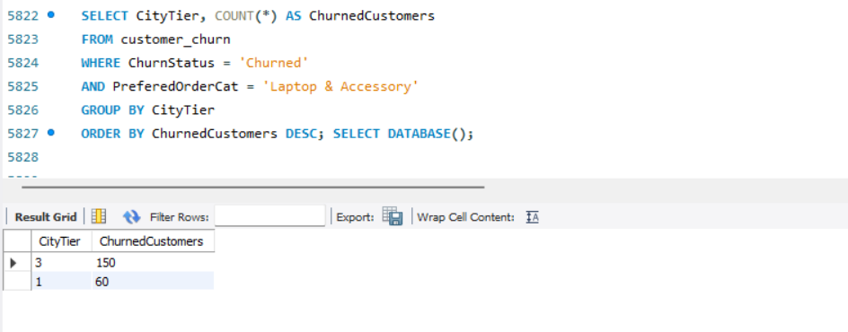
➢ Identify the most preferred payment mode among active customers.
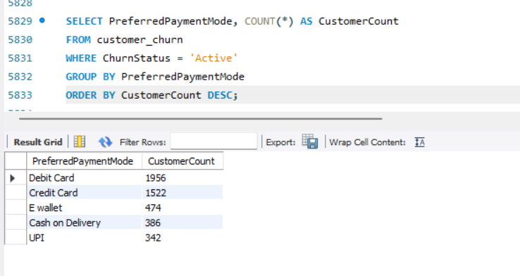
➢ Calculate the total order amount hike from last year for customers who are single and prefer mobile phones for ordering.
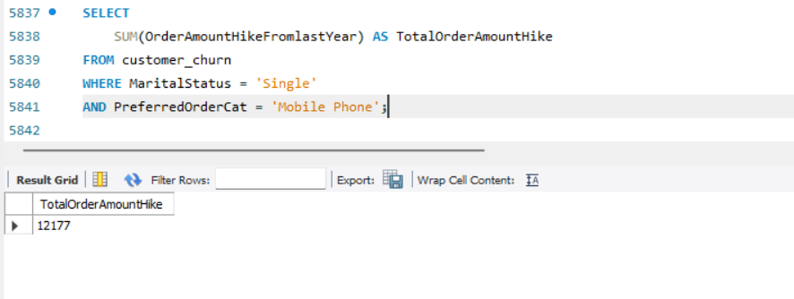
➢ Find the average number of devices registered among customers who used UPI as their preferred payment mode.

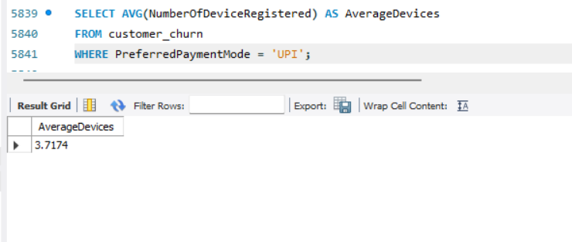
➢ Determine the city tier with the highest number of customers.
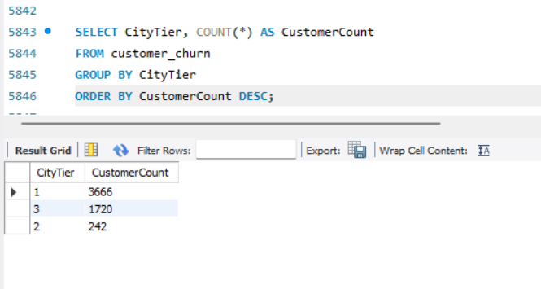
➢ Identify the gender that utilized the highest number of coupons.
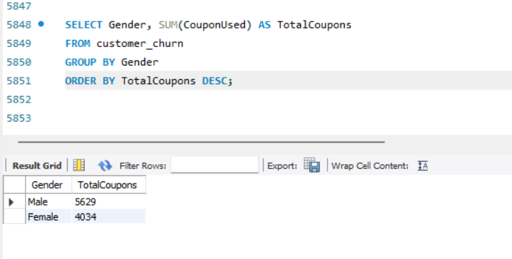
➢ List the number of customers and the maximum hours spent on the app in each preferred order category.
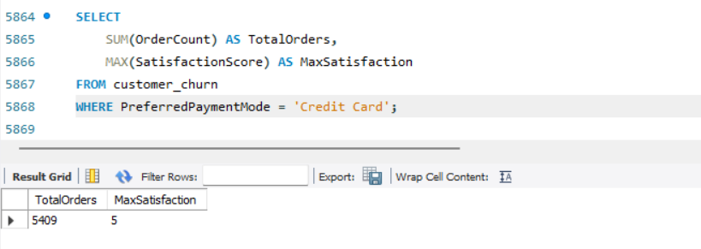
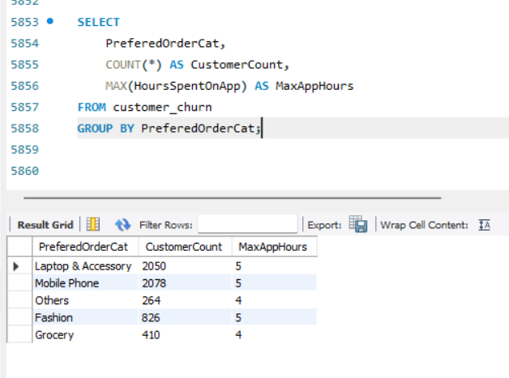
➢ Calculate the total order count for customers who prefer using credit cards and have the maximum satisfaction score.
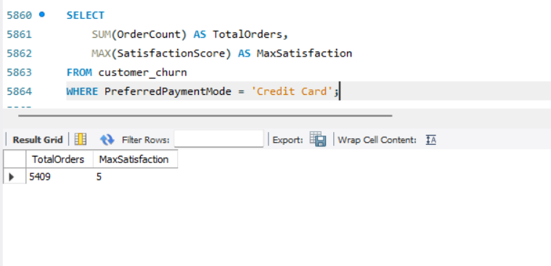
➢ What is the average satisfaction score of customers who have complained?
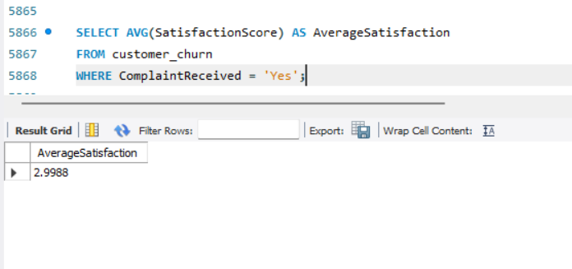
➢ List the preferred order category among customers who used more than 5 coupons.
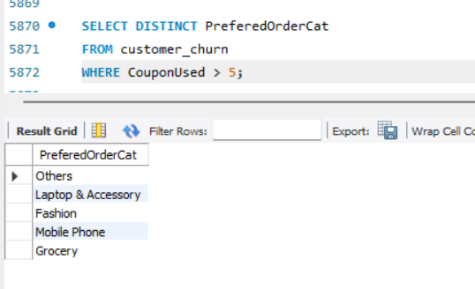

➢ List the top 3 preferred order categories with the highest average cashback amount.

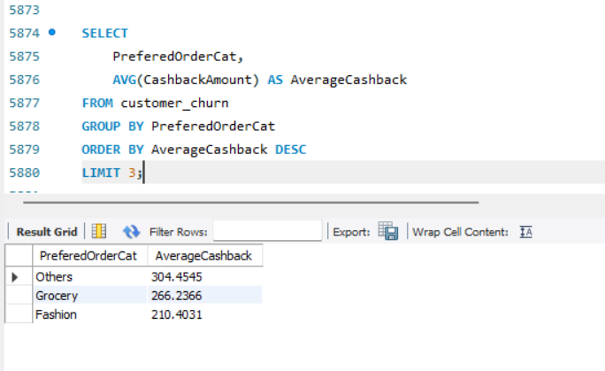
➢ Find the preferred payment modes of customers whose average tenure is 10 months and have placed more than 500 orders.
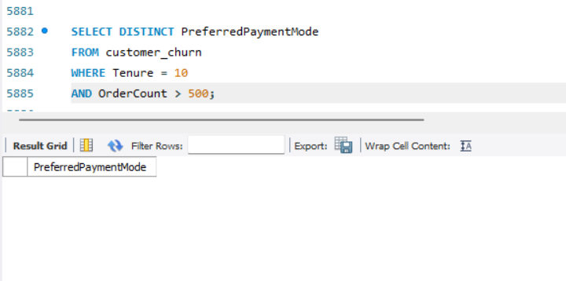
➢ Categorize customers based on their distance from the warehouse to home such as 'Very Close Distance' for distances <=5km, 'Close Distance' for <=10km, 'Moderate Distance' for <=15km, and 'Far Distance' for >15km. Then, display the churn status breakdown for each distance category.

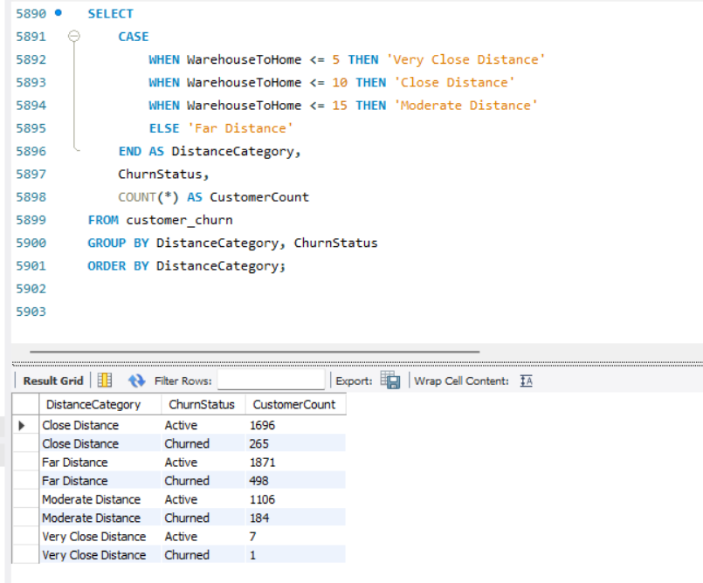
➢ List the customer’s order details who are married, live in City Tier-1, and their order counts are more than the average number of orders placed by all customers.
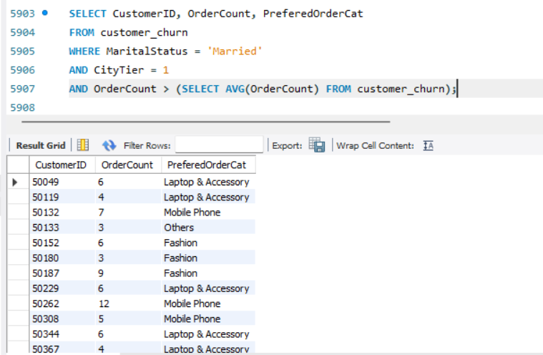
➢ a) Create a ‘customer_returns’ table in the ‘ecomm’ database and insert the following data:
b) Display the return details along with the customer details of those who have churned and have made complaints.
